1. open git-bash and access particular local directory

2. mkdir git-localconfig-repo

3. cd git-localconfig-repo

4. git init

5. open notepad++, select language as properties , paste some properties in this file like

limits-service.minimum=3

limits-service.maximum=997 and save as limits-service

6. git add . & git commit -m "adding limits-service properties in git-localconfig-repo"

7. pwd enter and copy the file location(/d/My-Works/Java-Springboot-WS/udemy/udemy-java-springboot/microservices-practice-project/git-localconfig-repo) from git-bash

8. spring.cloud.config.server.git.uri=file://D:/My-Works/Java-Springboot-WS/udemy/udemy-java-springboot/microservices-practice-project/git-localconfig-repo

Note :- spring.cloud.config.server.git.uri=file://file location

or

**we can create centralized github repo for all env variables and in application.properties we will add this where centralized-config-server is centralized git repo where we will commit all our env files like application.properties , limits-service.properties**

**spring.cloud.config.server.git.uri=https://github.com/ranjeet93ks/centralized-config-server**

**http://localhost:8888/actuator/default -- it will display details of application.properties**

**http://localhost:8888/limits-service/default -- it will display details of application.properties as well as limits-service.properties**

9. @EnableConfigServer && SpringBootApplication

10. hit--> http://localhost:8888/limits-service/default in chrome after restart server

11. Add Jason Formatter plugin in chrome as o/p of this url will be in jason format

12. http://localhost:8080/limits --> data will fetch from limts-service.properties present in git-localconfig-repo folder.

13. create limits-service-qa and limits-service-dev in git-localconfig-repo folder and change the properties values

14. hit--> http://localhost:8888/limits-service/dev in chrome after restart server -> corresponding values along with default values

15. hit--> http://localhost:8888/limits-service/qa in chrome after restart server -> corresponding values along with default values

16. for different microservices, we can multiple properties file here like microservice-x.properties,microservice-x-dev.properties,microservice-x-qa.properties

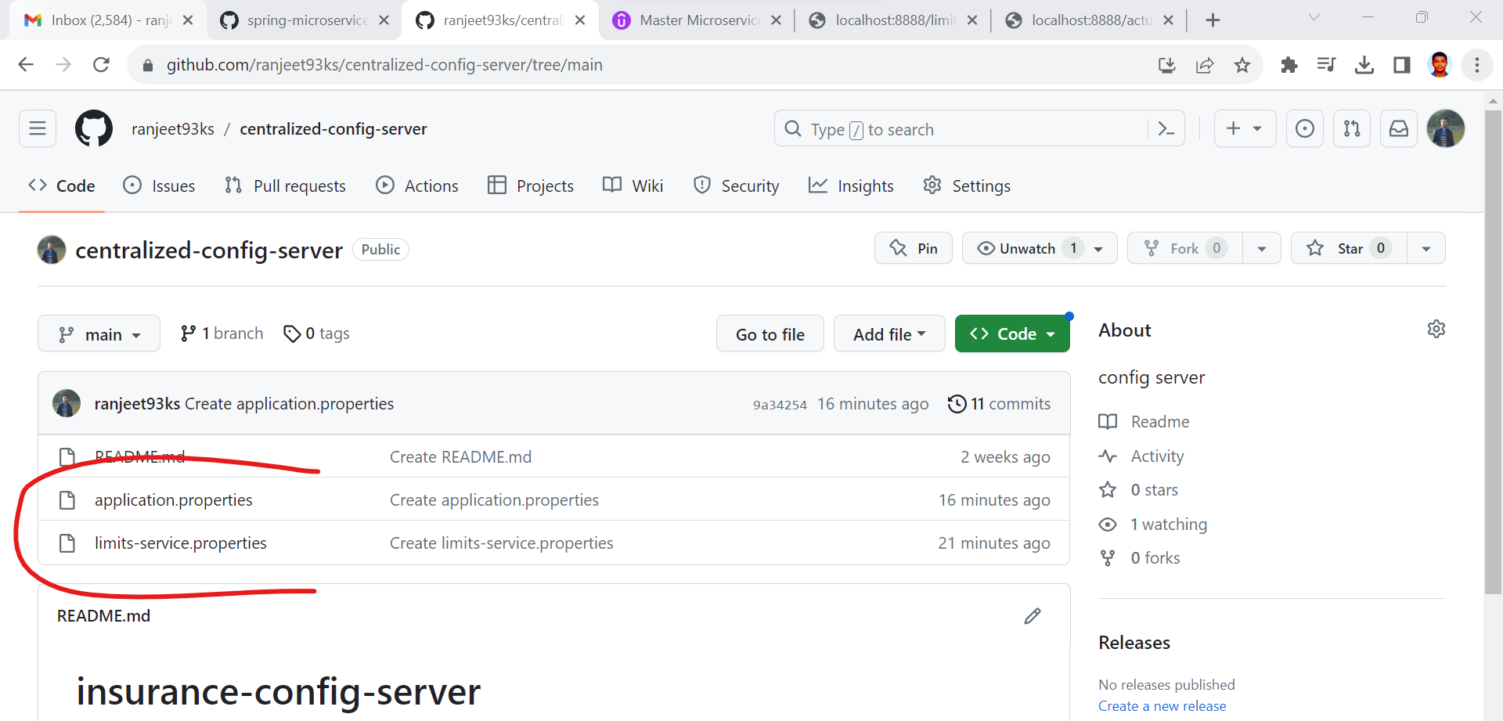

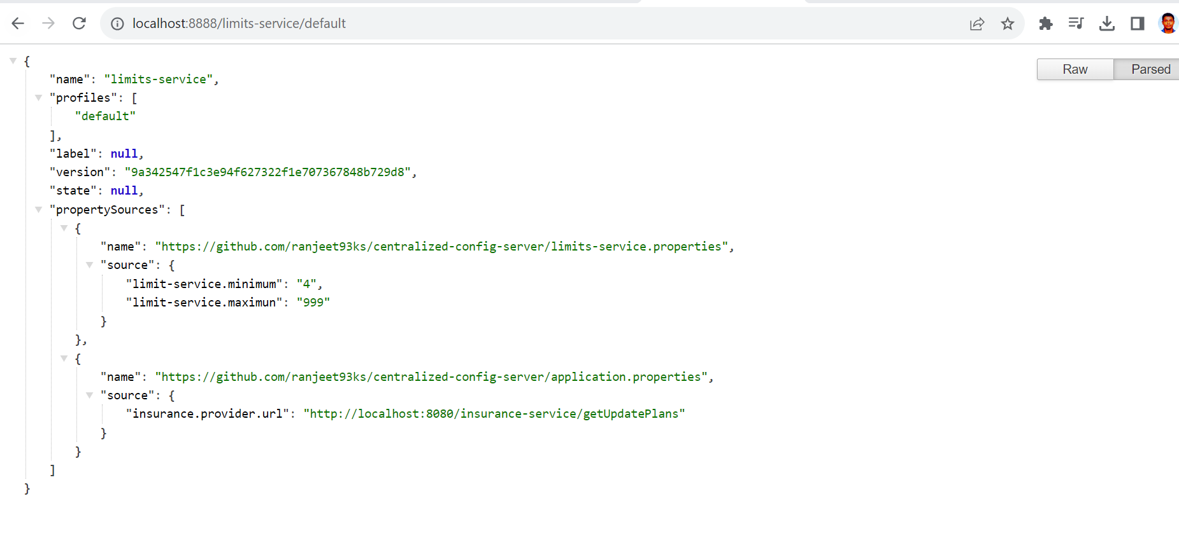

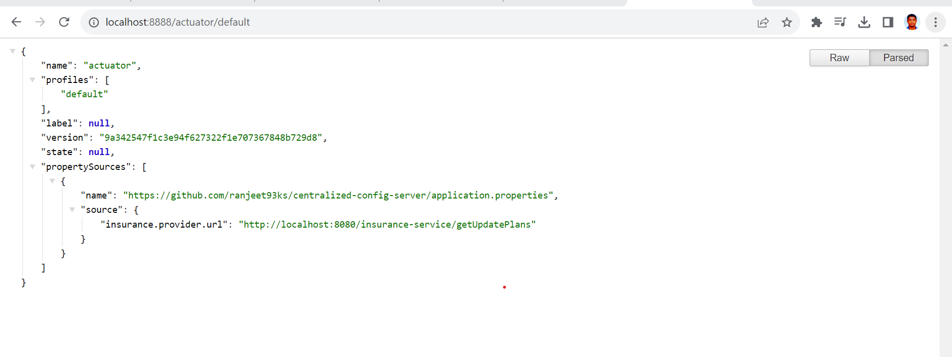

End ----